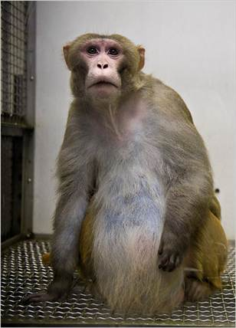
Photo by Leah Nash for the New York Times

